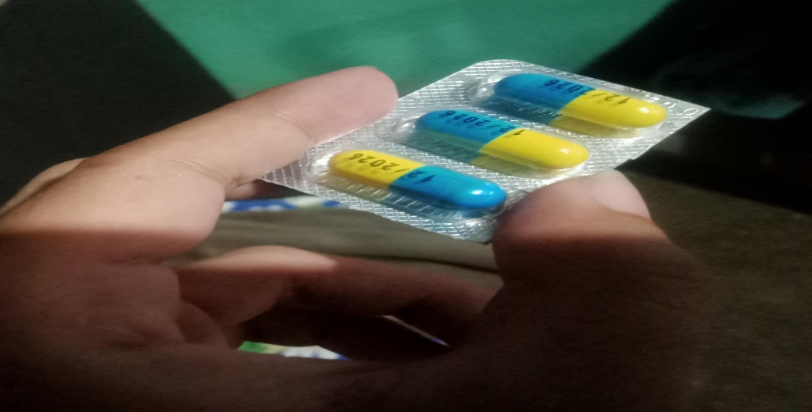

1. **What is in the photo?**  In this photo, you can see I’m holding a blister pack of antibiotic capsules. Each capsule is divided into two colors, blue and yellow, and sealed in clear plastic packaging. This type of medicine is commonly used to treat bacterial infections and is usually prescribed by doctors.
2. **How does it show science or technology?** This medicine is a result of advanced pharmaceutical science, which involves studying bacteria and creating compounds to fight them. The production of capsules requires precise technology in laboratories and manufacturing facilities. Even the packaging uses specific materials to keep the medicine effective and safe.
3. **How does it impact or help society?** Antibiotics play a major role in public health by curing infections that could become serious or life-threatening. They help people recover faster, reduce the risk of complications, and prevent the spread of diseases. This allows communities to stay healthy and productive, especially during times when illnesses are common.